Interview Exchange Step by Step Guide for
Student Employment Request to Post Form
This guide will assist managers when they are seeking to post a student employment position.
If you would like to see more screen shots than what is provided below please review this User Manual link: https://support.interviewexchange.com/articles/hirezon-hr-forms/start-new-form-by-employee-user-role

- Log into Hirezon utilizing the following link: Login (interviewexchange.com)

- Select the Forms module.

- Select Start New Form in the upper right.

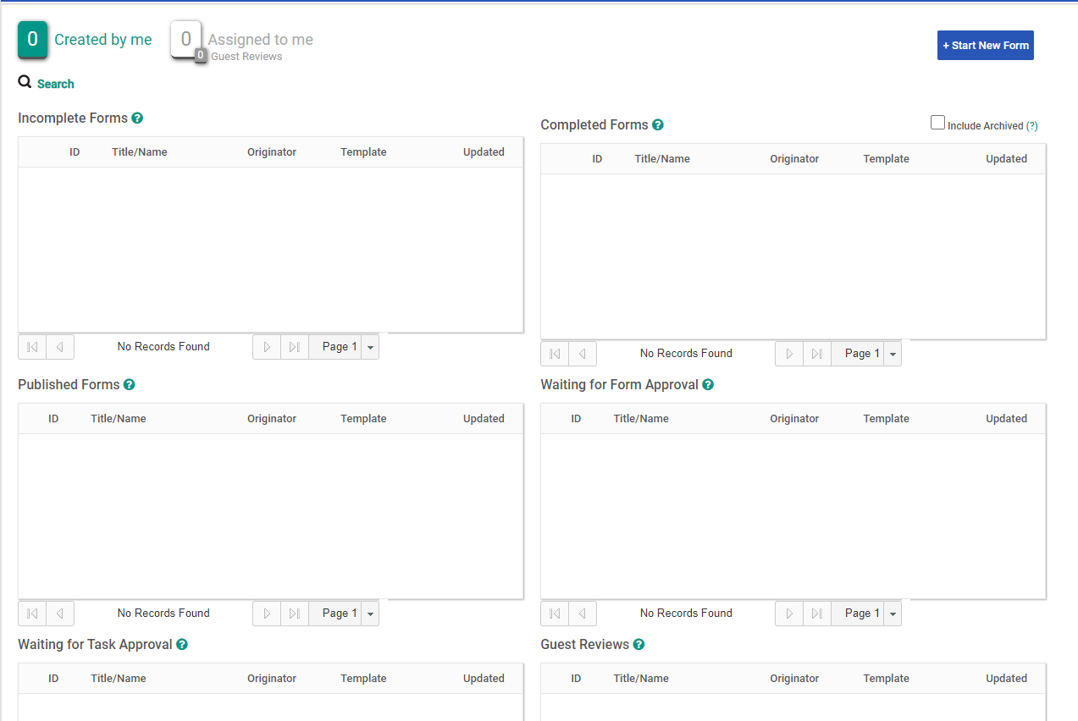

- In the Department drop-down, select the correct department for this position.

A pop-up window will appear asking the user to ensure the department selected in accurate. If the department selected is correct, click OK. If the department is incorrect, click Cancel and update.

Note: If the department is wrong and not fixed during this step, you cannot fix it later, you will be forced to start over.

- In the Category dropdown, select Recruitment.

- In the Template dropdown, select the appropriate form, in this case Student Position - Request to Post.

- Before you enter a Title/Name click on “OR Use Job Template Library” to select the specific template for a student position. Select “Student Job”

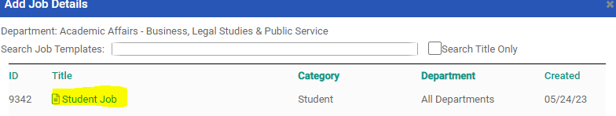

Scroll down to the bottom of the template and click on “Use This Job Template”

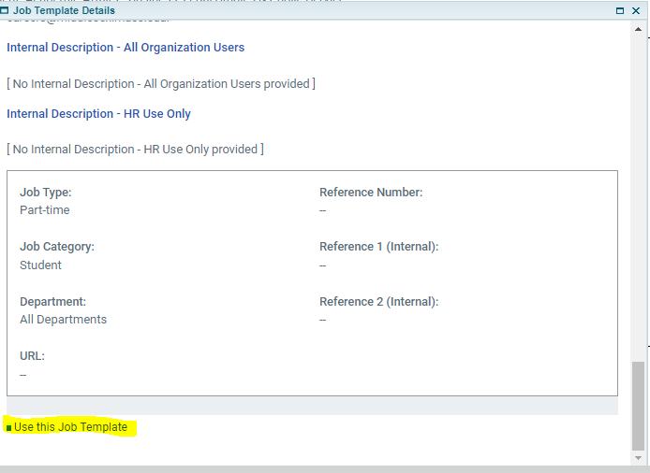

- Update the title of the student job in the Title/Name field. Do not abbreviate. Type the title out in full how you want it to be displayed on your website.

- Click Create Form.
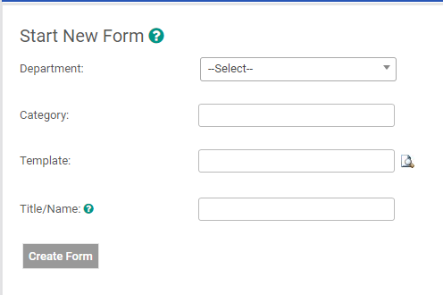

- You will be directed to the page where you will complete the Request to Post section of the form.

- Click on Student Request to Post/Hire Form.
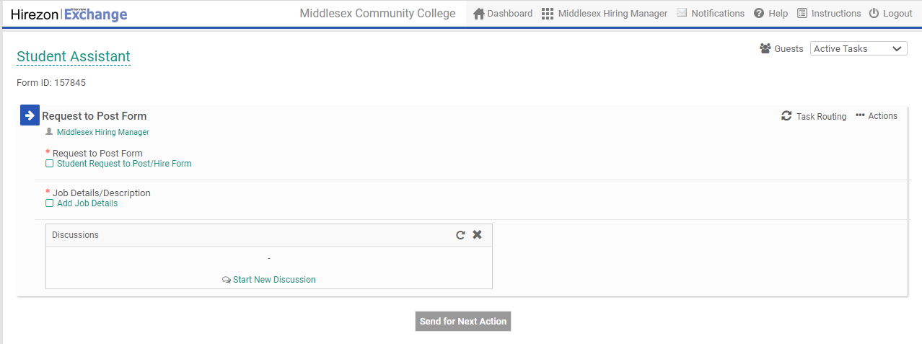

- Complete the form with all the required and pertinent information.

Note: All fields with a * are required. You will not be able to submit this form for approval without all the required fields being completed.

- Once you have completed the Student Request to Post/Hire Form, click Save & Submit.

- Review to ensure all the information is accurate.
  - If changes need to be made, click Edit and make any necessary changes.
  - Once all the information is accurate, click Continue.

- Once you click Continue, you will be directed to the Request to Post page again. You will now see a checkmark next to the Student Request to Post/Hire Form.

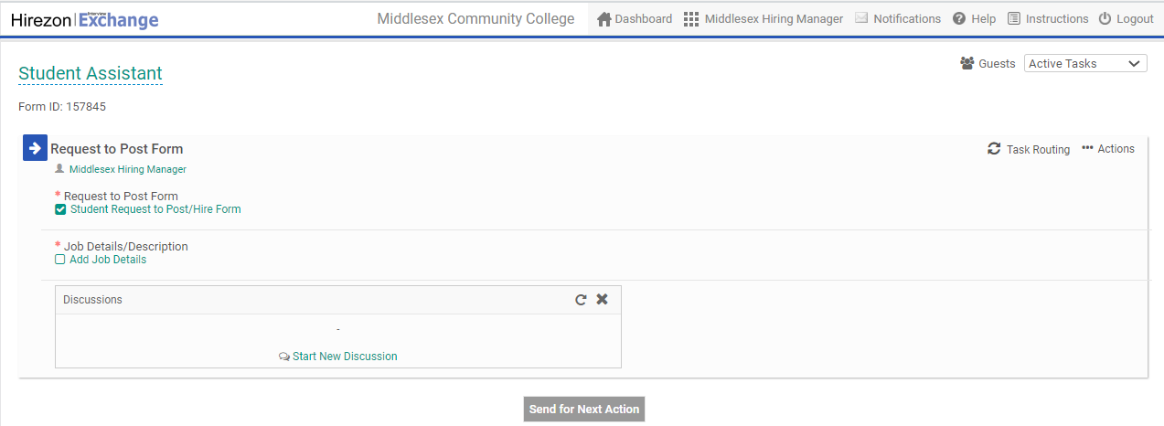

- Click on Add Job Details in the Job Details area.

- Complete the required areas of Job Details page based on the position description.

Note: The position title will be pre-populated, other fields may also be pre-populated based on your system configuration (i.e., Company Description, Application Instructions etc.)

- Once all the required fields have been completed click Save Job Details.

- Review to ensure all the information is accurate.

Note: This is a preview of the job posting, so please review closely to ensure the information is exactly how you wish it to appear in the job advertisement.
  - If changes need to be made, click Edit and make any necessary changes.
  - Once all the information is accurate, click Close.

- Once you click Close, you will be directed to the Request to Post page. You will now see a checkmark next to the title under job description.

- The Request to Post is now ready to be sent for approval which is done by clicking the Send for Next Action at the bottom of the page.

- One-by-one, in linear order, approvers in the task routing will receive an email to approve.

Notes:
- Please click here to see the User Manual link on Approving a form.
- Changes made during the approval process are tracked.
- You can view the status of the approval process at any time by going back into the form and clicking on Task Routing.
- If the Student Request to Post/Hire Form is denied for some reason during the approval process, the originator of the form will receive an email notification. The individual that denied should include the reason for the denial so the originator can update the position accordingly and resubmit, if applicable. Once the initiator makes the necessary corrections, the approval process will start over from the beginning. All denial and change information will be stored for audit purposes. Please click here for more information from the User Manual.

- Assuming the request is approved, the job will be posted by HR, click here for User Manual link.
- Candidates will apply and be reviewed by the search committee.
- Once a finalist is chosen you can begin the Recommendation section of the form by logging into your account, go to the Assigned to me section of your dashboard, click the Edit icon (square and pencil) next to the correct form.
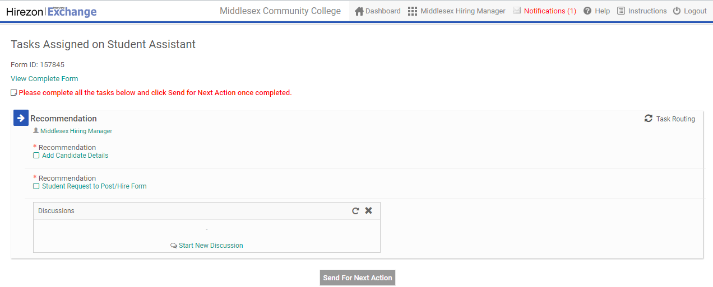
- Once you come to the Recommendation section you can complete the Student Request to Post/Hire Form just as you did in the previous section (see numbers 11-15).
- Instructions on how to Add Candidate Details can be found here.
- Once there is a checkmark in both sections you can click Send For Next Action to initiate the approval process.
- You will receive email confirmation once the Recommendation section has been fully completed, at which time your HR team will initiate the Onboarding processes.

