Interview Exchange Step-by-Step Guide for Exit Form
The Exit Form is used whenever an employee, regardless of classification or full-time/part-time status leaves the College, for any reason. Reasons may include, but are not limited to, resignation, retirement, end of assignment, discharge/termination, etc. The form must be filled out and any resignation notice/email submitted by the employee must be attached. This form replaces the need for managers or supervisors to forward emails to HR when an employee indicates they are leaving the College. The process also allows for IT, Facilities, Public Safety, Administrative Services and Human Resources to be notified of the exit of the employee in a timely manner.
- After signing into Interview Exchange, click on the Interview Exchange Forms Module:

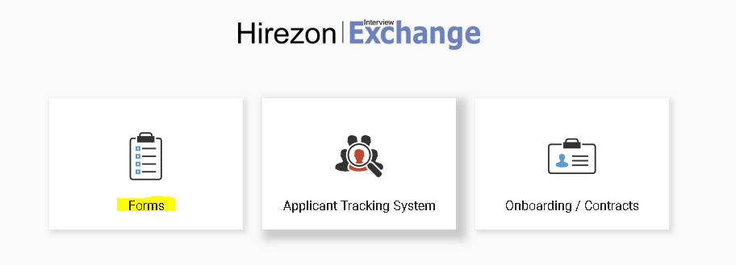
- This screen is called your “Dashboard”. This is where you will see all forms that you’ve completed or are still pending. Click on “Start New Form”.
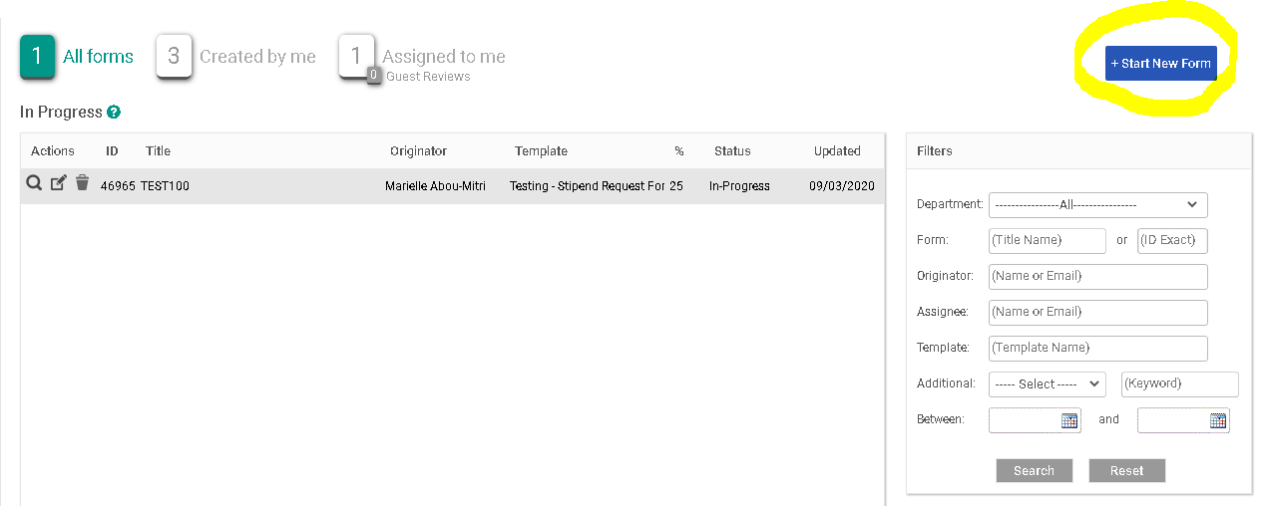
- The next screen is the “Start New Form” screen.
  - You will be required to select the correct department from the Department dropdown list. Note: You will not be able to change the department once the form is created.
  - Select the corresponding category from the Category (Personnel) dropdown.
  - Select the required template from the Template (Employee- Exit/Termination Form) dropdown. Once the template is selected, you can preview the template by clicking the magnifying glass icon.
  - Enter a Position Title/Name in the Title/Name field.
  - Click Create Form.
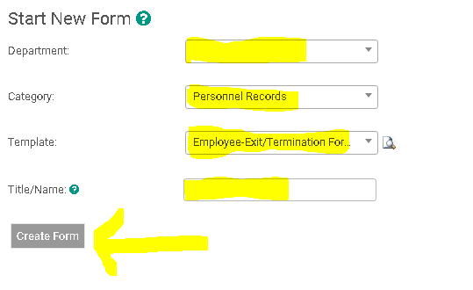
- After you click on “Create Form” you will be directed to the following page to complete a series of tasks. Click on “Employee Exit/Termination Form”.
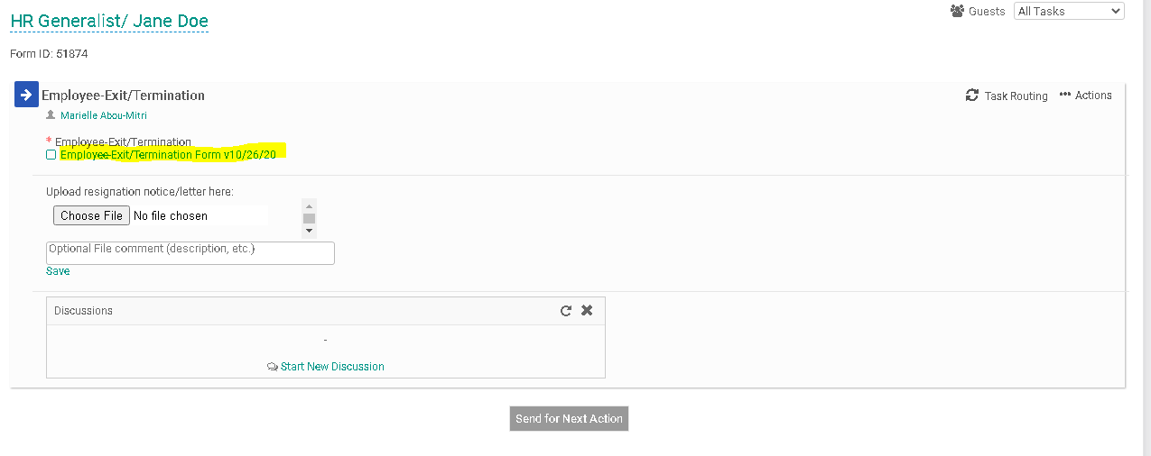
- Fill out the specific information in the required fields regarding the employee leaving the College. The direct supervisor/manager should fill out information in all headings except: “HR Office Use”, “Information Technology Use” and “Benefits Information”. Once the form has been completed click on “Save & Submit”.
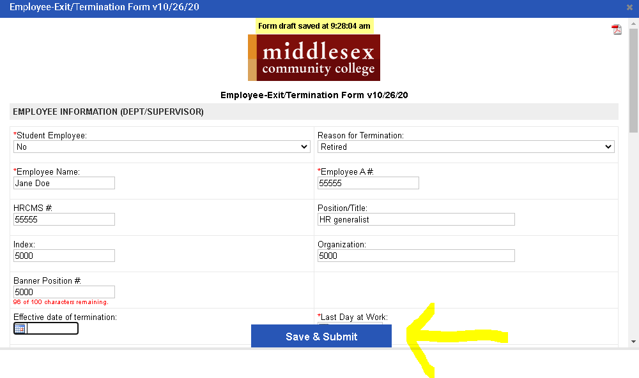
- You will then be prompted to review the information you submitted on the form. You can click “Edit” if you would like to make changes. Otherwise, click “Continue”
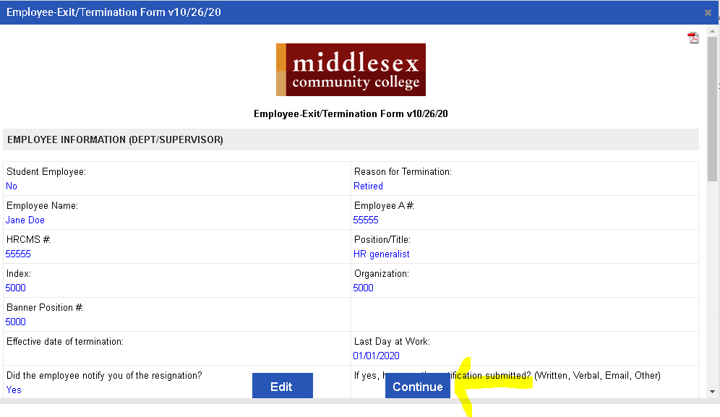

- Your screen should now indicate a small check mark in front of the “Employee- Exit/Termination Form” to indicate that you’ve completed this task.
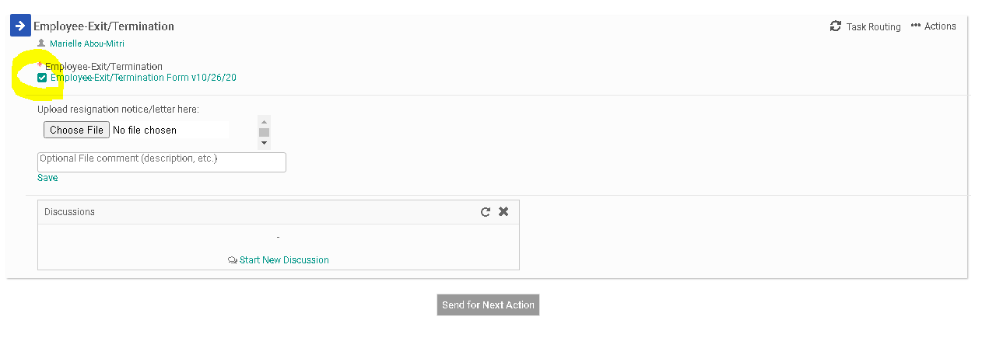
- Now click on “Choose File” to upload any resignation notice, letter, or email that was submitted by the employee. If there is no resignation notice to submit move on to step #9 below.
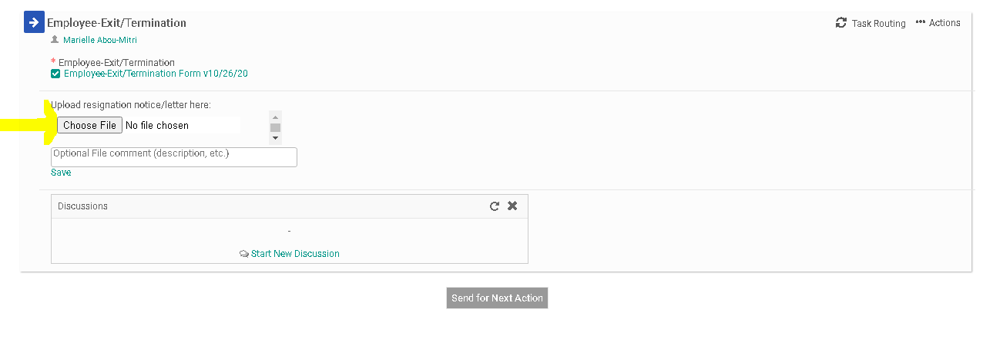
- Your next step will be to generate the Task Routing process so all parties involved may be notified about the employee’s exit from the College. Click on “Task Routing” to begin this process.
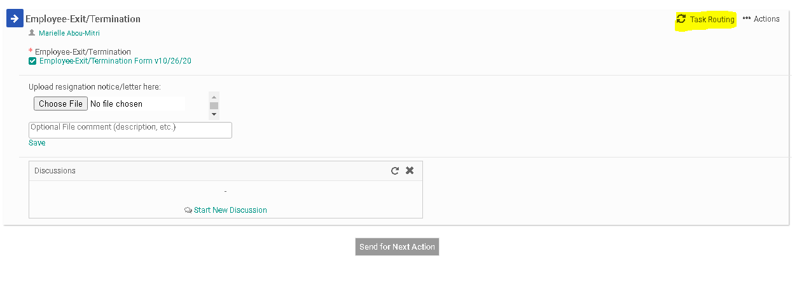
- Certain people in the task routing screen are prepopulated. On the Exit/Termination Form, the only party that is not prepopulated is the “Department Supervisor/Manager”. If you are the Department Supervisor/Manager you will need to enter your own name in this field and approve the form in order for it to proceed to the next person in the task routing. Click on the Edit Routing User Icon (highlighted below) alongside the Department Supervisor/Manager to enter a name for this field.
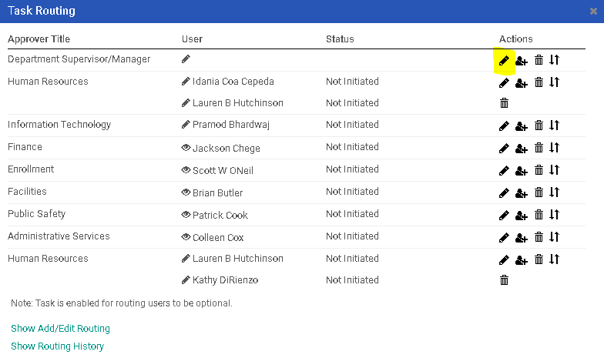
- Enter the Department Supervisor/Manager into the “User” field. As you type this person’s name, the system will recognize people with accounts in the system and will prepopulate the field. You may search by first or last name. Click “Save Routing” once you have entered the field.
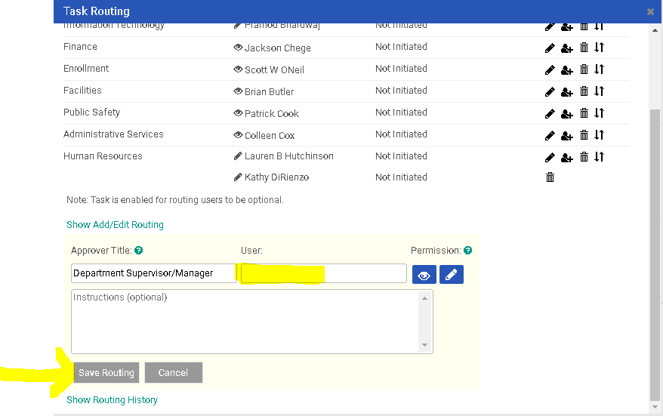
- Next, you will need to click on “Send for Next Action”. This will allow for each person in the task routing field to review the Exit/Termination Form and approve/deny/edit it. Each person in the task routing field receives an email notification when it is their turn to review the form.
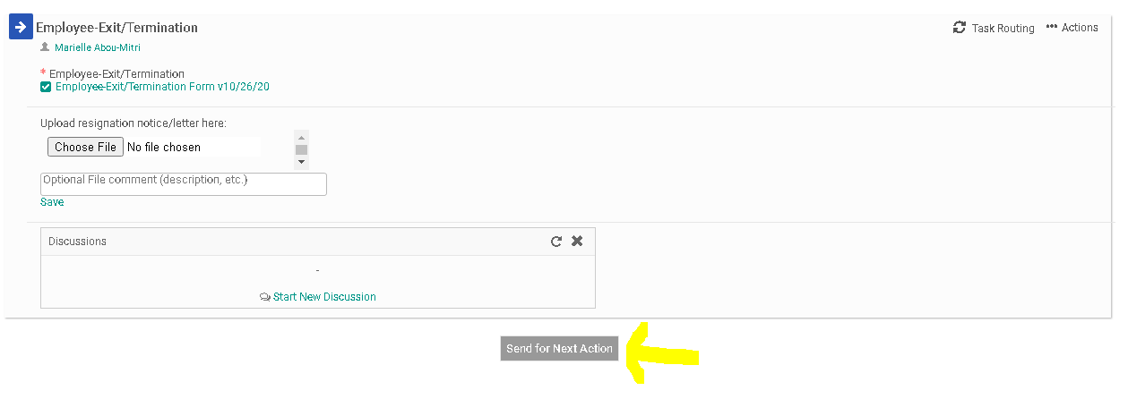
- If you are one of the approvers in the Task Routing of the form, please review the Interview Exchange Step-by-Step Guide for Task Routers.

