Interview Exchange Step-by-Step Guide for Student Hire Form
The Student Hire Form is used for all student employee positions (non-work study) with expiring annual or short term contracts. This form replaces the student JAF and can be used for returning and new student employees. Once the Student Hire Form is generated and approved by the task approvers, the Hiring Manager generates an Employment Contract to the employee through the Onboarding Module.
Note: Supervisors/Managers who hire and onboard non-work study student employees will need additional access to the Onboarding Module within Interview Exchange to access and process important documents for student hires. If you are a supervisor that generally hires student employees, please contact an HR administrator to inquire about getting access to the onboarding module within the Interview Exchange system.

- After signing into Interview Exchange, click on the Interview Exchange Forms Module:
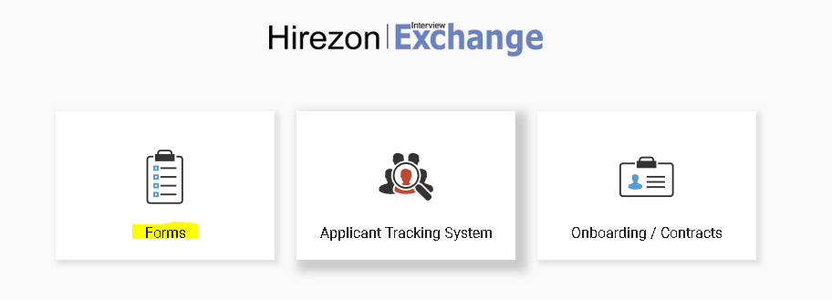
- This screen is called your “Dashboard”. This is where you will see all forms that you’ve completed or are still pending. Click on “Start New Form”.
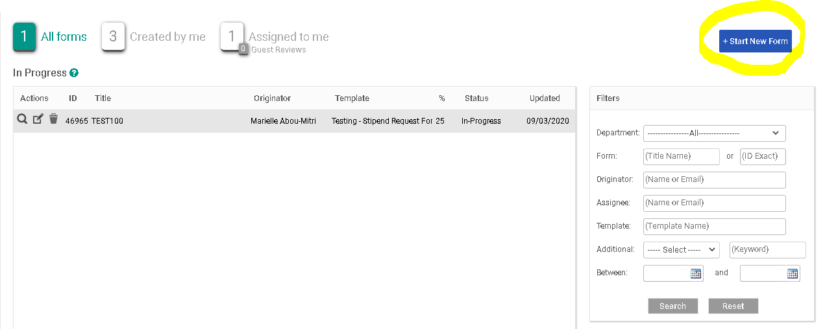
- The next screen is the “Start New Form” screen.
  - You will be required to select the correct department from the Department dropdown list. Note: You will not be able to change the department once the form is created.
  - Select the corresponding category from the Category (Recruitment) dropdown.
  - Select the required template from the Template (Student Hire Form) dropdown. Once the template is selected, you can preview the template by clicking the magnifying glass icon.
  - Enter a Position Title/Name in the Title/Name field.
  - Click Create Form.
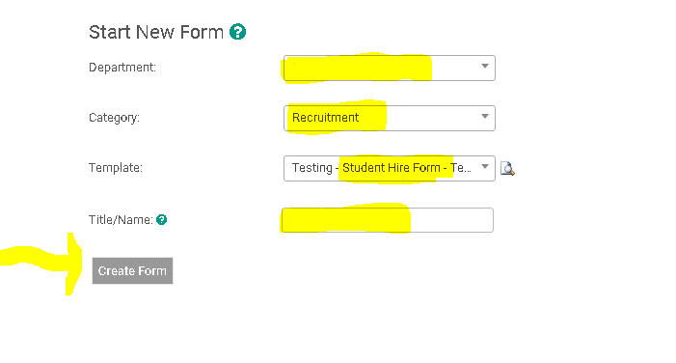
- After you click on “Create Form” you will be directed to the following page to complete a series of tasks. Click on “Student Hire Request Form”.
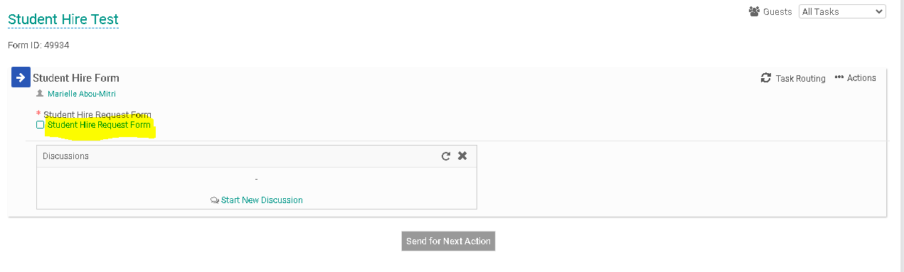
- Fill out the specific information in the required fields regarding the student hire. This information includes (1) Student Employee’s Personal Information; (2) Employment Classification Group; (3) Compensation; (4) Student Confirmation; (5) Work Schedule and Location and (6) Budget Information. When you have finished filling out the form click, “Save & Submit”.
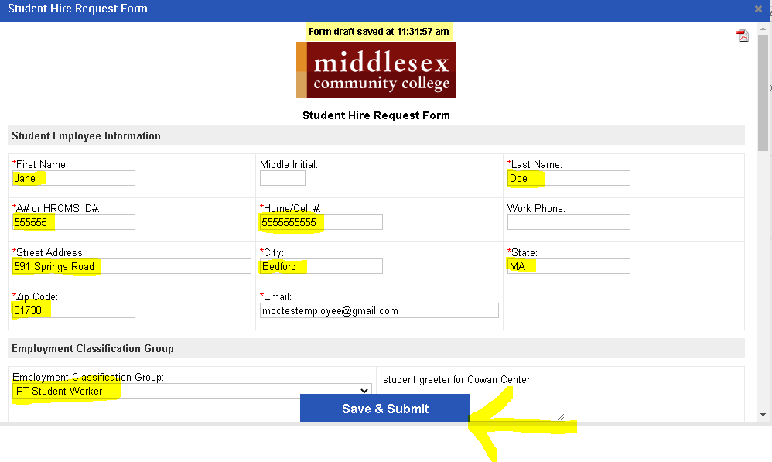
- You will then be prompted to review the information you submitted on the form. You can click “Edit” if you would like to make changes. Otherwise, click “Continue”
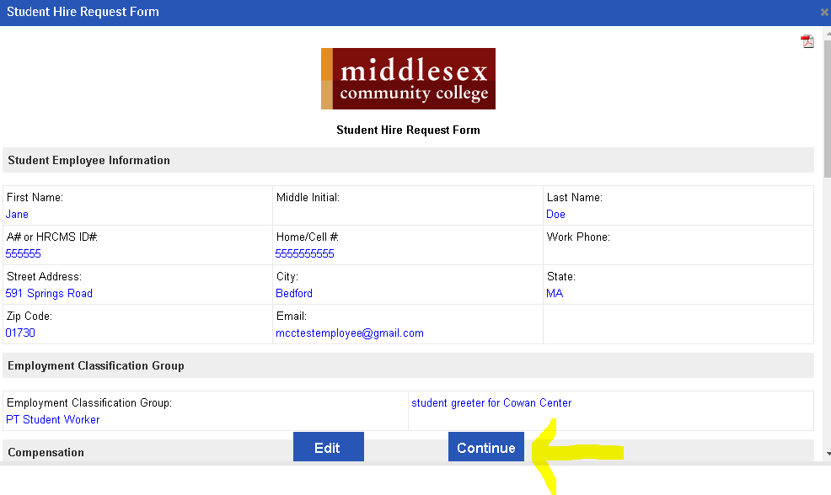

- Your screen should now indicate a small check mark in front of the “Student Hire Form” to indicate that you’ve completed this task.
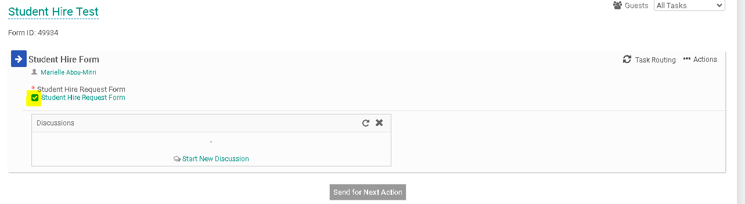
- Your next step will be to generate the Task Routing process so all parties involved may approve your Renewal Request Form. Click on “Task Routing” to begin this process.
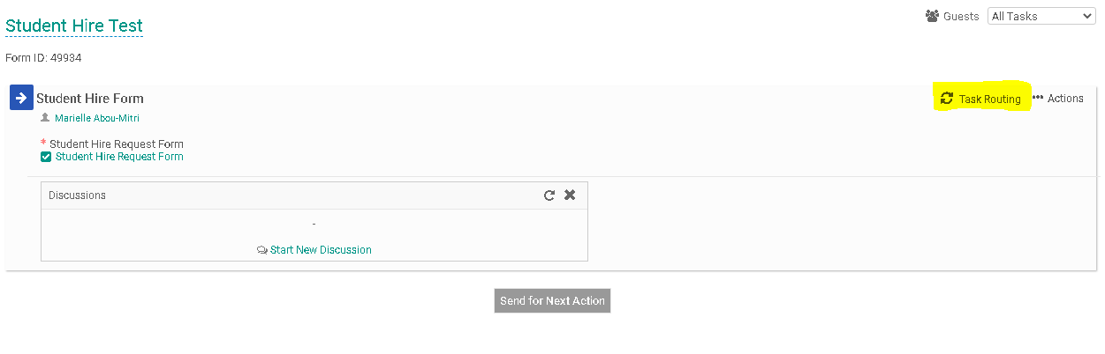
- Certain people in the task routing screen are prepopulated. On the Student Hire Form, the Human Resources and Finance representatives are prepopulated. The person filling out the Renewal Request Form will be required to enter a name for the “Hiring/Cost Center Manager” and the “Senior Leader/Cabinet Representative”. Click on the Edit Routing User Icon (highlighted below) alongside the Hiring/Cost Center Manager to enter a name for this field.
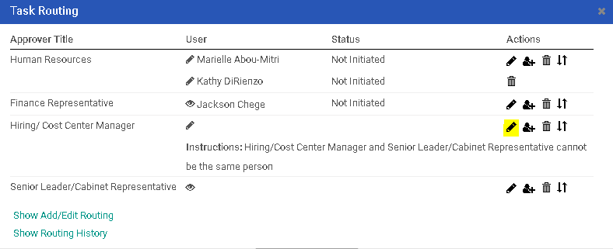
- Enter the Hiring/Cost Center Manager into the “User” field. As you type this person’s name, the system will recognize people with accounts in the system and will prepopulate the field. You may search by first or last name. Click “Save Routing” once you have entered the field.
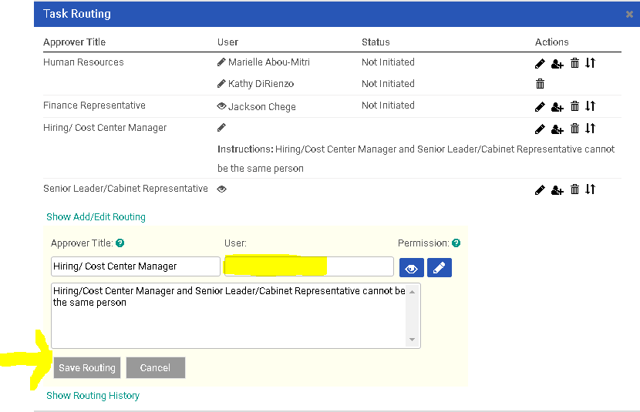
- You will be required to complete the same action for the Senior Leader/Cabinet Representative. Click on the Edit Routing User Icon (highlighted below) alongside the Senior Leader/Cabinet Representative to enter a name for this field.
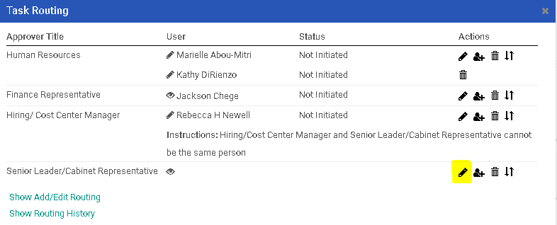

- Enter the Senior Leader/ Cabinet Representative into the “User” field. As you type this person’s name, the system will recognize people with accounts in the system and will prepopulate the field. You may search by first or last name.Click “Save Routing” once you have entered the field.
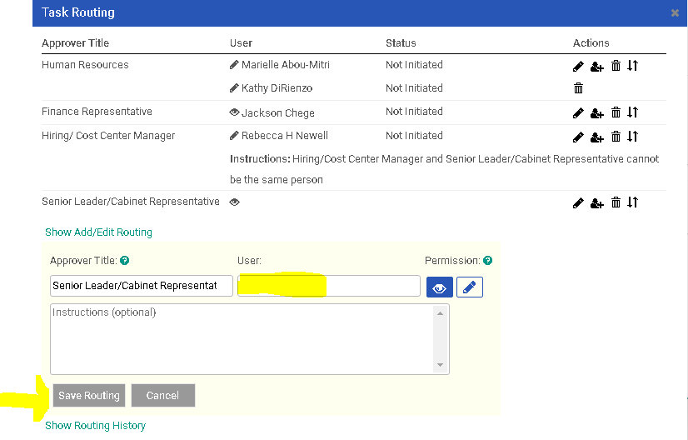
- Next, you will need to click on “Send for Next Action”. This will allow for each person in the task routing field to review the Student Hiring Form and approve/deny/edit it. Each person in the task routing field receives an email notification when it is their turn to review the form.
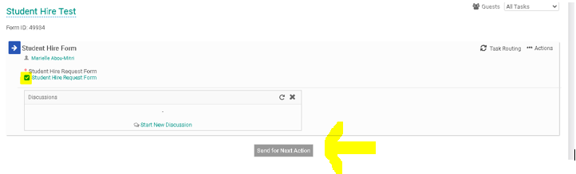
- If you are one of the approvers in the Task Routing of the form, please review the Interview Exchange Step-by-Step Guide for Task Routers.
- If you are the hiring manager that will be onboarding the student employee, please review the Interview Exchange Step-by-Step Guide for Student Employee Onboarding.

